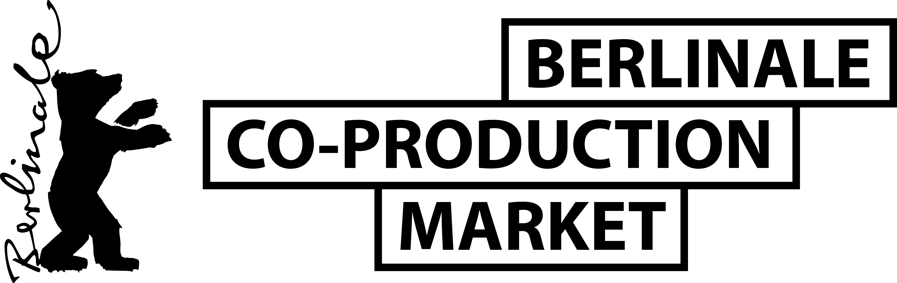
VISITORS PROGRAMME 2022
REGISTRATION FORM*

Information for publication in the Visitors Brochure
Company
Country
First Name
Last Name
Phone
Mobile
E-mail
Website
Short Company Profile (max. 700 characters incl. spaces)
3 recent film credits of the company - Use the following format:
TITLE by director, year, country/ies of origin, festival premiere, awards
(and please specify: feature, doc, short, animation, VR, drama series)

Representative’s Photo
Please attach as jpeg or png file

Please return the completed form as a Word document together with a headshot to your contact at the institution that is inviting you to participate in the Visitors Programme.

PLEASE NOTE

- By registering for the Visitors Programme, you agree that your information in this form will be published in the Visitors Brochure of the Berlinale Co-Production Market.

- Please note that additionally to being registered in the Visitors Programme, every Visitor needs to be a holder of a Berlinale Festival accreditation and/or EFM Market Badge (recommended for optimum access to online services and contacts). You can find the fees and deadlines on the Berlinale website. You can benefit from the Early Bear rate until 6 December and the Regular Rate until 6 January.

- For on-location participation, the Berlinale COVID-19 regulations apply. Please check the page and the overall travel rules regularly to see if you are eligible for on-location participation.

- Most sessions are planned to be accessible both online and on-site. A part of the programme, such as the Visitors Meet & Match, might be held entirely online, to facilitate for all Visitors to jointly attend together and meet each other.

- As a Visitor, you will not have the opportunity to book meetings with our projects and/or present your project in public and you will not be part of our official Participants Directory. This is reserved for those participants, who have international co-production experience.

